
Hobie Queensland
State Championships
5th – 7th October 2024
SAILING INSTRUCTIONS


ORGANISING AUTHORITY

LAKE COOTHARABA SAILING CLUB
24 Boreen Parade

The notation ‘[NP]’ in a rule means that a boat may not protest another boat for breaking that rule.
This changes RRS 60.1(a).
The notation [DP] in a rule means that the penalty for a breach of the rule may, at the discretion of the protest committee be less than disqualification. This changes Rule 64.2

1. RULES
1.1. The event is governed by the rules as defined in The Racing Rules of Sailing.
1.2. The Australian Sailing prescriptions and special regulations Part 2 apply.
1.3. The Class rules of the International Hobie Association shall apply
1.4. Appendix T – Arbitration will apply.
1.5 Competitors must follow all Club Policies (https://lcsc.org.au)
1.6 Racing Rule 40 will be changed as follows:
Competitors shall wear personal flotation devices whilst afloat, except briefly while changing or adjusting clothing or personal equipment. Wet suits and dry suits are not personal flotation devices. Changes RRS Rule 40.

2. CHANGES TO SAILING INSTRUCTIONS
2.1 Any Change to the sailing instructions will be posted before 0900 on the day it will take effect except that changes to the schedule of races will be posted by 2000 on the day before it will take effect..

3. COMMUNICATIONS WITH COMPETITORS
3.1. Notices to the competitors will be posted on the official notice board located on the ground floor adjacent to the clubs stairs
3.2. Signals made ashore will be displayed on the clubhouse flagpole.
3.3. When flag AP is displayed ashore, “1 minute is replaced with not less than 30 minutes’. This changes RRS race signals.

4. CODE OF CONDUCT
4.1. [DP] Competitors and support persons shall comply with reasonable requests from the race officials.

5. SCHEDULE
5.1.
Date | Event | Time/First Warning
5/10/2024 | Registration  Briefing  First Warning not before | 0900 hrs-1000 hrs  1100 hrs  1230 hrs  Maximum 3 races back-to-back
6/10/2024 | First Warning not before  Dinner at the Pub | 1000hrs  Morning - 2-3 races back-to-back  Return to shore - Lunch Break  Afternoon - 2-3 races back-to-back  Maximum of 3 races back-to-back  1830hrs
7/10/2024 | First Warning not before  Presentation | 1000 hrs  Target of 3 races back-to-back Maximum of 4 races back-to-back\\ Presentation at LCSC Club House.  As soon as possible After Racing
5.2. On the last scheduled day of racing no warning signal will be made after 1430
5.3. A maximum of 11 races are scheduled.
5.4. No more than 3 races shall be sailed on any one Session with the exception of the last day.
5.5. In an effort to keep the regatta entry fee to a minimum, there will be no formal presentation dinner for this event. The presentation will be held as soon as possible following completion of racing in the club house.

7. CLASS FLAGS
7.1. The class flags are:
Class / Division | Class Flag Description
Division 2 Hobie 14 | Green flag with black insignia.
Division 2 Hobie 14 Turbo | Green flag with black insignia
Division 1 Hobie 16 | Dark Blue flag with Black insignia
- RACING AREA
8.1. SI Attachment A shows the location of the racing area.

9. COURSES
9.1. The diagram in SI Attachment B shows the courses, including the approximate angles between legs, the order in which marks are to be passed, and the side on which each mark is to be left.
9.2. No later than the warning signal, the race committee signal vessel will display the approximate compass bearing of the first leg.
9.3. Hobie 14 & Hobie 14 Turbo class shall round inner weather mark ‘A’, all other classes shall round weather mark ‘1’ (see SI Attachment B).
- MARKS
10.1. Marks 1,4s & 4p are yellow Buoys.
10.2. Mark A is a Pink Buoy.
10.3. Mark 3 is a red/white chequer buoy. (Start Pin)
10.4. Marks 1a and finish are red tear drops.

11. THE START
11.1. The starting line is between a staff displaying an orange flag on the signal vessel at the starboard end and a Red -White chequer buoy at the port end.
11.2. Boats whose warning signal has not been made shall avoid the starting area during the starting sequence for other races.
11.3. A boat that does not start within four (4) minutes after her starting signal will be scored Did Not Start without a hearing. This changes RRS A5.1 and A5.2.

12. CHANGE OF THE NEXT LEG OF THE COURSE
12.1. No change to the course will be made during racing.

13. THE FINISH
13.1. The finishing line is between a staff displaying blue flag on the finish vessel and the Finish buoy.

14. PENALTY SYSTEM
14.1. RRS 44.1 is changed so that the Two-Turns Penalty is replaced by the One-Turn Penalty.

15. TIME LIMITS AND TARGET TIMES
15.1. The Target Time, Race Time Limit (see RRS 35), and the Finishing Window are shown in the table below.
Target Time | Race Time Limit | Finishing Window
40 minutes | 60 minutes | 15 minutes

15.2. The Finishing Window is the time for boats to finish after the first boat sails the course and finishes. Boats failing to finish within the Finishing Window, and not subsequently retiring, penalized or given redress, will be scored Time Limit Expired (TLE) without a hearing. A boat scored TLE shall be scored points for the finishing place one more than the points scored by the last boat that finished within the Finishing Window. This changes RRS 35, A5.1, A5.2 and A10.
15.3. Failure to meet the Target Time will not be grounds for redress. This changes RRS 62.1(a).

16. HEARING REQUESTS
16.1. For each class, the protest time limit is 60 minutes after the last boat [in that class] finishes the last race of the day or the race committee signals no more racing today, whichever is later. The time will be posted on the official notice board.
16.2. Hearing request forms are available from the LCSC Sailing Office.
16.3. Notices will be posted no later than 30 minutes after the protest time limit to inform competitors of hearings in which they are parties or named as witnesses. Hearings will be held at a time and place advised on the hearing notice.

17. SCORING
17.1. Four races are required to be completed to constitute a series.
17.2. When fewer than 4 races have been completed, a boat’s series score will be the total of her race scores.
17.1.2. When 4 to 8 races have been completed, a boat’s series score will be the total of her race scores excluding her worst score.
17.4. When 9 or more races have been completed, a boat’s series score will be the total of her race scores excluding her 2 worst scores.

18. [NP] SAFETY REGULATIONS
18.1. [SP] A boat that retires from a race shall notify the race committee at the first reasonable opportunity.

19. REPLACEMENT OF CREW OR EQUIPMENT
19.1. [DP] Substitution of competitors is not allowed without prior written approval of the race committee.
19.2. [DP] Substitution of damaged or lost equipment is not allowed unless authorized in writing by the race committee. Requests for substitution shall be made to the committee at the first reasonable opportunity, which may be after the race.

20. EQUIPMENT AND MEASUREMENT CHECKS
20.1. A boat or equipment may be inspected at any time for compliance with the class rules, notice of race and sailing instructions.
20.2. [DP] When instructed by a race official on the water, a boat shall proceed to a designated area for inspection.

21. OFFICIAL VESSELS
21.1. Official vessels may be identified by display of a white flag with back letters ‘RC’ or red letters ‘MEDIA’.

22. [DP] SUPPORT TEAMS
22.1. Team leaders, coaches and other support persons shall stay outside areas where boats are racing from the time of the preparatory signal for the first start until all boats have finished or retired or the race committee signals a postponement, general recall or abandonment.
23. TRASH DISPOSAL
23.1. Trash may be placed aboard official or support person vessels.

24. RISK STATEMENT
24.1. RRS 3 states: ‘The responsibility for a boat’s decision to participate in a race or to continue to race is hers alone.’ By participating in this event each competitor agrees and acknowledges that sailing is a potentially dangerous activity with inherent risks. These risks include strong winds and rough seas, sudden changes in weather, failure of equipment, boat handling errors, poor seamanship by other boats, loss of balance on an unstable platform and fatigue resulting in increased risk of injury. Inherent in the sport of sailing is the risk of permanent, catastrophic injury or death by drowning, trauma, hypothermia or other causes.

25. INSURANCE
25.1. Each participating boat shall be insured with valid third-party personal and property liability insurance with a minimum cover of $10 million per event or the equivalent. By entering the event, each competitor declares that they have the required insurance cover. LCSC will not be liable if a competitor declares that they have insurance and it subsequently transpires that this was not true

26. FURTHER INFORMATION
. LCSC Website https://lcsc.org.au/contact/
Qld Hobie Class Association: Andrew Warneke 0403 806 897 or Rob Branch 0402 982 913

Attachment A - Racing Area
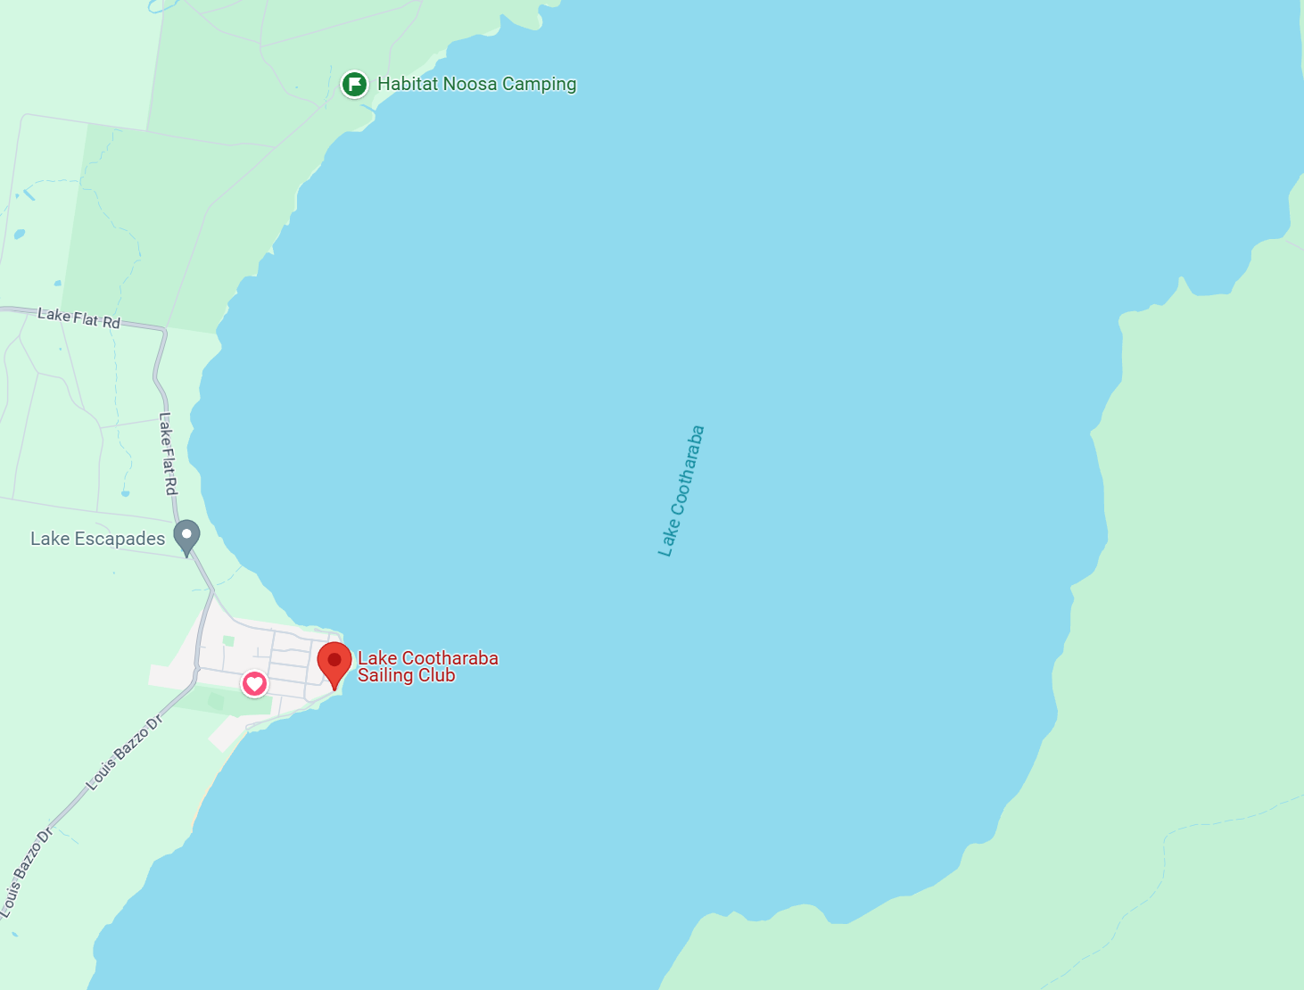
Approximate course location

Attachment B - Courses

111111
1
1a

A

4s 4p
111111
111111

Finish



3 -----------Start-------------

Division 1 Hobiecat 16, Start, 1,1a,4p/4s,1,1a,4p,finish
Division 2 Hobiecat 14, Start, A ,4p/4s, A ,4p, finish

